DLD LAB 05 TASK SUBMISSION
NAME: YASH RAJ
ROLL NUMBER: 24K-0737

Exercise # 1:
Use K-Map to find expression for Carry and Sum for Full Adder. Use Truth Table in manual (also implement).

TRUTH TABLE:
A | B | Cin | Sum | Cout
0 | 0 | 0 | 0 | 0
0 | 0 | 1 | 1 | 0
0 | 1 | 0 | 1 | 0
0 | 1 | 1 | 0 | 1
1 | 0 | 0 | 1 | 0
1 | 0 | 1 | 0 | 1
1 | 1 | 0 | 0 | 1
1 | 1 | 1 | 1 | 1

Sum Expression Using K-Map:
ABC + A’B’C + A’BC’ + AB’C’
C(AB+A’B’) +C’(A’B+AB’)
X’C +C’X == A XOR B XOR C
Logic Circuit:
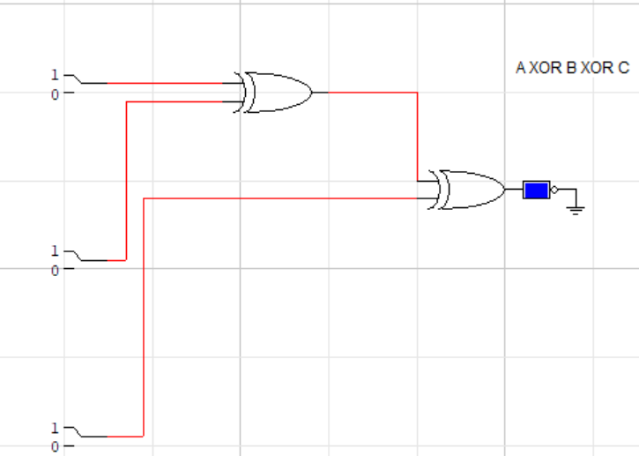

Cout Expression Using K-Map:
AB+BC+AB’C

Logic Circuit:
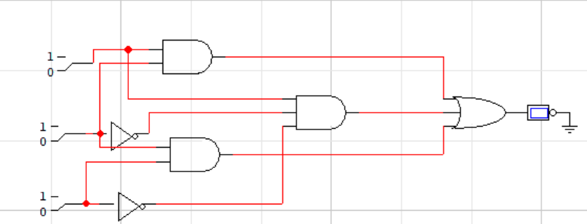
Exercise # 3
Create a 2-bit subtracter circuit and implement it on breadboard along with truth table.
BOOLEAN EXPRESSIONS
D = A’B’Bin + AB’Bin’+ A’BBin’ + ABBin = A ⊕ B ⊕ B_{in}
Bout = A’Bin + A’B + BBin

Logic Circuit:
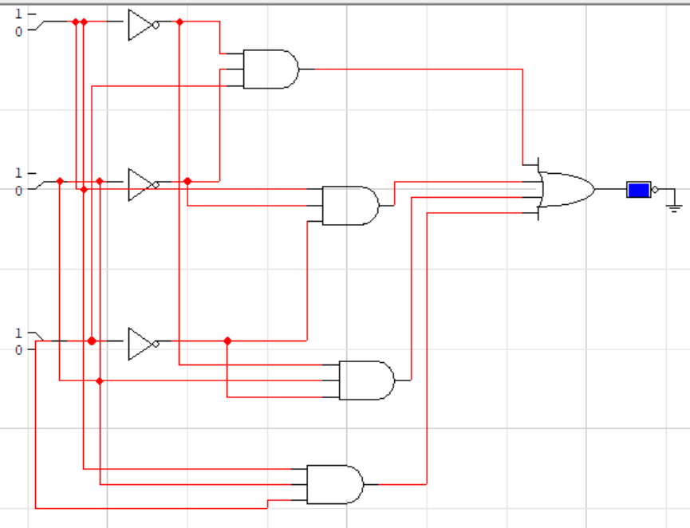

Truth Table:
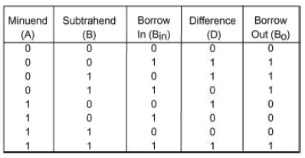
Exercise # 4
Create a 2-bit binary multiplier along with its truth table and multiply the number 11 and 11.
Truth Table:
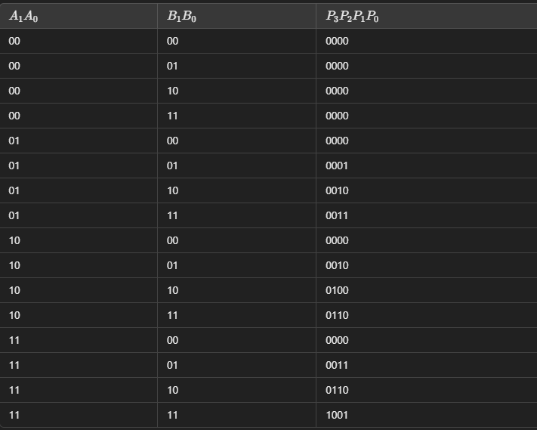
Multiplication:
(11)2 x (11)2 = 3 x 3 = 9
(9)10 = (1001)2

